**ACACIA**

*rootDMC*

$treatment

diff lwr upr p adj

flooded-control -0.03255002 -0.069952393 0.004852351 0.0989843

recovery-control 0.01284659 -0.025174042 0.050867227 0.6919045

recovery-flooded 0.04539661 0.007375979 0.083417249 0.0159784

*fineRootDMC*

$treatment

diff lwr upr p adj

flooded-control 0.01774378 -0.01676933 0.052256887 0.4311268

recovery-control -0.02096223 -0.05604584 0.014121380 0.3239311

recovery-flooded -0.03870601 -0.07378962 -0.003622399 0.0276973

*dryFineRootMass*

Fit: aov(formula = dryFineRootMass ~ treatment * CO2, data = traits.A)

$treatment

diff lwr upr p adj

flooded-control -1.8291250 -2.52187112 -1.1363789 0.0000003

recovery-control -1.0749083 -1.77910558 -0.3707111 0.0017388

recovery-flooded 0.7542167 0.05001942 1.4584139 0.0334436

$CO2

diff lwr upr p adj

E-A 0.1090934 -0.3657495 0.5839362 0.6451149

$`treatment:CO2`

diff lwr upr p adj

flooded:A-control:A -1.7408750 -2.94497563 -0.5367744 0.0012732

recovery:A-control:A -1.1086786 -2.35504113 0.1376840 0.1062017

control:E-control:A 0.1522500 -1.05185063 1.3563506 0.9989206

flooded:E-control:A -1.7651250 -2.96922563 -0.5610244 0.0010610

recovery:E-control:A -0.9026250 -2.10672563 0.3014756 0.2420953

recovery:A-flooded:A 0.6321964 -0.61416613 1.8785590 0.6562496

control:E-flooded:A 1.8931250 0.68902437 3.0972256 0.0003993

flooded:E-flooded:A -0.0242500 -1.22835063 1.1798506 0.9999999

recovery:E-flooded:A 0.8382500 -0.36585063 2.0423506 0.3172610

control:E-recovery:A 1.2609286 0.01456601 2.5072911 0.0459578

flooded:E-recovery:A -0.6564464 -1.90280899 0.5899161 0.6196636

recovery:E-recovery:A 0.2060536 -1.04030899 1.4524161 0.9961228

flooded:E-control:E -1.9173750 -3.12147563 -0.7132744 0.0003310

recovery:E-control:E -1.0548750 -2.25897563 0.1492256 0.1157409

recovery:E-flooded:E 0.8625000 -0.34160063 2.0666006 0.2874309

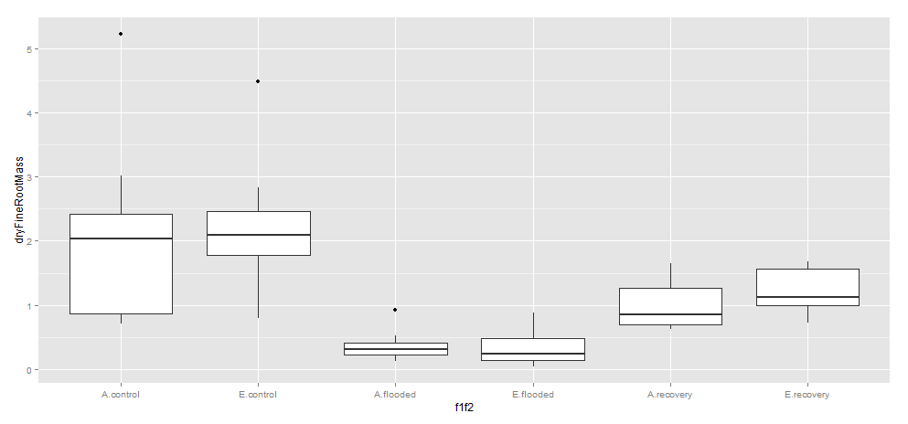

*dryCoarseRootMass*

Fit: aov(formula = dryCoarseRootMass ~ treatment * CO2, data = traits.A)

$treatment

diff lwr upr p adj

flooded-control -2.770375 -3.664479 -1.8762709 0.0000000

recovery-control -0.535200 -1.444084 0.3736836 0.3342607

recovery-flooded 2.235175 1.326291 3.1440586 0.0000014

$CO2

diff lwr upr p adj

E-A 0.3000167 -0.312847 0.9128804 0.3286426

$`treatment:CO2`

diff lwr upr p adj

flooded:A-control:A -2.6658750 -4.2199671 -1.1117829 0.0001037

recovery:A-control:A -0.7920536 -2.4006917 0.8165846 0.6837315

control:E-control:A 0.2227500 -1.3313421 1.7768421 0.9980295

flooded:E-control:A -2.6521250 -4.2062171 -1.0980329 0.0001128

recovery:E-control:A -0.1016250 -1.6557171 1.4524671 0.9999574

recovery:A-flooded:A 1.8738214 0.2651833 3.4824596 0.0142012

control:E-flooded:A 2.8886250 1.3345329 4.4427171 0.0000262

flooded:E-flooded:A 0.0137500 -1.5403421 1.5678421 1.0000000

recovery:E-flooded:A 2.5642500 1.0101579 4.1183421 0.0001927

control:E-recovery:A 1.0148036 -0.5938346 2.6234417 0.4253180

flooded:E-recovery:A -1.8600714 -3.4687096 -0.2514333 0.0152102

recovery:E-recovery:A 0.6904286 -0.9182096 2.2990667 0.7925422

flooded:E-control:E -2.8748750 -4.4289671 -1.3207829 0.0000286

recovery:E-control:E -0.3243750 -1.8784671 1.2297171 0.9886038

recovery:E-flooded:E 2.5505000 0.9964079 4.1045921 0.0002095

*SLA*

$treatment

diff lwr upr p adj

flooded-control -3.124783 -5.181189 -1.068377 0.0018256

recovery-control 0.908263 -1.182135 2.998661 0.5460971

recovery-flooded 4.033046 1.942648 6.123445 0.0000878

*LDMC*

$treatment

diff lwr upr p adj

flooded-control -0.01388145 -0.073084374 0.04532147 0.8366755

recovery-control 0.06756221 0.007380666 0.12774376 0.0246833

recovery-flooded 0.08144367 0.021262120 0.14162521 0.0057212

*shootDMC*

$treatment

diff lwr upr p adj

flooded-control 0.03411818 -0.04333854 0.1115749 0.5371613

recovery-control 0.08205372 0.00331664 0.1607908 0.0394806

recovery-flooded 0.04793554 -0.03080154 0.1266726 0.3106989

**CASUARINA – check C23**

*rootDensity*

$treatment

diff lwr upr p adj

flooded-control -0.06962602 -0.09366010 -0.04559195 0.0000000

recovery-control -0.00836328 -0.03239735 0.01567079 0.6767922

recovery-flooded 0.06126274 0.03761950 0.08490599 0.0000005

*rootDMC*

$treatment

diff lwr upr p adj

flooded-control -0.053082601 -0.07374843 -0.03241677 0.0000006

recovery-control -0.003125718 -0.02379155 0.01754011 0.9282819

recovery-flooded 0.049956883 0.02962710 0.07028666 0.0000014

*coarseRootDMC*

$treatment

diff lwr upr p adj

flooded-control -0.04413334 -0.07020536 -0.0180613222 0.0005225

recovery-control -0.06949793 -0.09556994 -0.0434259080 0.0000003

recovery-flooded -0.02536459 -0.05101264 0.0002834679 0.0531368

$CO2

diff lwr upr p adj

E-A 0.02550348 0.007923022 0.04308394 0.0055213

$`treatment:CO2`

diff lwr upr p adj

flooded:A-control:A -0.021983186 -0.06656350 0.022597125 0.6823767

recovery:A-control:A -0.040661774 -0.08524208 0.003918538 0.0916687

control:E-control:A 0.063162562 0.01701756 0.109307568 0.0025308

flooded:E-control:A -0.007331768 -0.05191208 0.037248543 0.9962170

recovery:E-control:A -0.039382352 -0.08396266 0.005197959 0.1104613

recovery:A-flooded:A -0.018678588 -0.06325890 0.025901724 0.8084463

control:E-flooded:A 0.085145748 0.03900074 0.131290754 0.0000299

flooded:E-flooded:A 0.014651418 -0.02992889 0.059231729 0.9209931

recovery:E-flooded:A -0.017399166 -0.06197948 0.027181145 0.8499393

control:E-recovery:A 0.103824336 0.05767933 0.149969342 0.0000006

flooded:E-recovery:A 0.033330006 -0.01125031 0.077910317 0.2446542

recovery:E-recovery:A 0.001279422 -0.04330089 0.045859733 0.9999993

flooded:E-control:E -0.070494330 -0.11663934 -0.024349324 0.0006032

recovery:E-control:E -0.102544914 -0.14868992 -0.056399908 0.0000008

recovery:E-flooded:E -0.032050584 -0.07663090 0.012529727 0.2836570

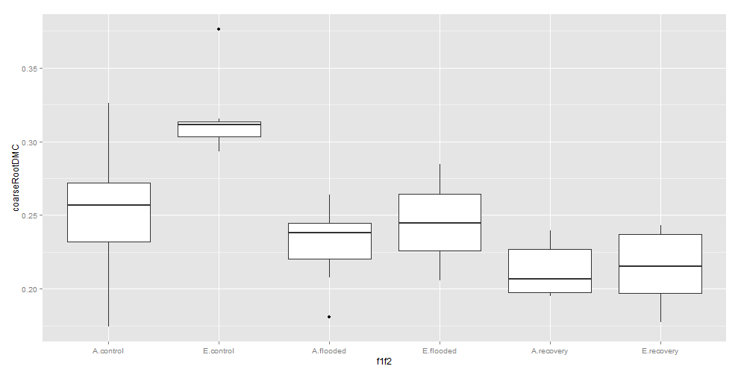

*fineRootDMC*

*something wrong with C17 fine root mass. Have changed it to be 1/10th…*

$CO2

diff lwr upr p adj

E-A 0.04506294 0.01017069 0.07995519 0.0126409

*dryFineRootMass*

Fit: aov(formula = dryFineRootMass ~ treatment * CO2, data = traits.C)

$treatment

diff lwr upr p adj

flooded-control -2.0877833 -3.0728713 -1.1026953 0.0000201

recovery-control -0.5205333 -1.5056213 0.4645547 0.4116296

recovery-flooded 1.5672500 0.5981807 2.5363193 0.0009072

$CO2

diff lwr upr p adj

E-A 1.008437 0.3441881 1.672685 0.0038302

$`treatment:CO2`

diff lwr upr p adj

flooded:A-control:A -0.9596875 -2.6440808 0.7247058 0.5378581

recovery:A-control:A 0.2938125 -1.3905808 1.9782058 0.9950146

control:E-control:A 2.4449375 0.7014248 4.1884502 0.0018804

flooded:E-control:A -0.9339375 -2.6183308 0.7504558 0.5668815

recovery:E-control:A 0.9470625 -0.7373308 2.6314558 0.5520707

recovery:A-flooded:A 1.2535000 -0.4308933 2.9378933 0.2491483

control:E-flooded:A 3.4046250 1.6611123 5.1481377 0.0000106

flooded:E-flooded:A 0.0257500 -1.6586433 1.7101433 1.0000000

recovery:E-flooded:A 1.9067500 0.2223567 3.5911433 0.0184524

control:E-recovery:A 2.1511250 0.4076123 3.8946377 0.0080690

flooded:E-recovery:A -1.2277500 -2.9121433 0.4566433 0.2696971

recovery:E-recovery:A 0.6532500 -1.0311433 2.3376433 0.8532655

flooded:E-control:E -3.3788750 -5.1223877 -1.6353623 0.0000122

recovery:E-control:E -1.4978750 -3.2413877 0.2456377 0.1287350

recovery:E-flooded:E 1.8810000 0.1966067 3.5653933 0.0208081

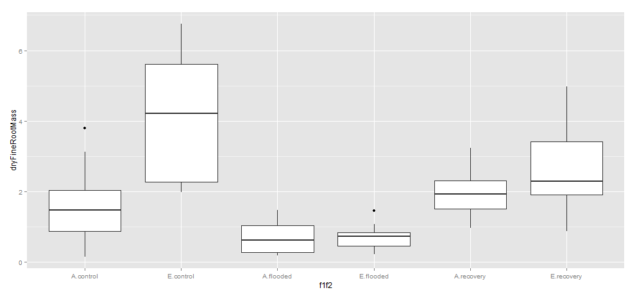

*dryCoarseRootMass*

Tukey multiple comparisons of means

95% family-wise confidence level

Fit: aov(formula = dryCoarseRootMass ~ treatment * CO2, data = traits.C)

$treatment

diff lwr upr p adj

flooded-control -3.9961042 -5.278054 -2.7141539 0.0000000

recovery-control -0.9656042 -2.247554 0.3163461 0.1720891

recovery-flooded 3.0305000 1.769396 4.2916041 0.0000021

$CO2

diff lwr upr p adj

E-A 1.015382 0.1509577 1.879806 0.0224564

$`treatment:CO2`

diff lwr upr p adj

flooded:A-control:A -2.968625 -5.1606204 -0.77662964 0.0028744

recovery:A-control:A 0.227000 -1.9649954 2.41899536 0.9995906

control:E-control:A 2.650536 0.3816050 4.91946647 0.0138244

flooded:E-control:A -2.549750 -4.7417454 -0.35775464 0.0143898

recovery:E-control:A 0.315625 -1.8763704 2.50762036 0.9979859

recovery:A-flooded:A 3.195625 1.0036296 5.38762036 0.0011415

control:E-flooded:A 5.619161 3.3502300 7.88809147 0.0000001

flooded:E-flooded:A 0.418875 -1.7731204 2.61087036 0.9923874

recovery:E-flooded:A 3.284250 1.0922546 5.47624536 0.0007900

control:E-recovery:A 2.423536 0.1546050 4.69246647 0.0302444

flooded:E-recovery:A -2.776750 -4.9687454 -0.58475464 0.0061150

recovery:E-recovery:A 0.088625 -2.1033704 2.28062036 0.9999961

flooded:E-control:E -5.200286 -7.4692165 -2.93135496 0.0000004

recovery:E-control:E -2.334911 -4.6038415 -0.06597996 0.0404780

recovery:E-flooded:E 2.865375 0.6733796 5.05737036 0.0043289

*coarseRootDMC*

$treatment

diff lwr upr p adj

flooded-control -0.04413334 -0.07020536 -0.0180613222 0.0005225

recovery-control -0.06949793 -0.09556994 -0.0434259080 0.0000003

recovery-flooded -0.02536459 -0.05101264 0.0002834679 0.0531368

$CO2

diff lwr upr p adj

E-A 0.02550348 0.007923022 0.04308394 0.0055213

$`treatment:CO2`

diff lwr upr p adj

flooded:A-control:A -0.021983186 -0.06656350 0.022597125 0.6823767

recovery:A-control:A -0.040661774 -0.08524208 0.003918538 0.0916687

control:E-control:A 0.063162562 0.01701756 0.109307568 0.0025308

flooded:E-control:A -0.007331768 -0.05191208 0.037248543 0.9962170

recovery:E-control:A -0.039382352 -0.08396266 0.005197959 0.1104613

recovery:A-flooded:A -0.018678588 -0.06325890 0.025901724 0.8084463

control:E-flooded:A 0.085145748 0.03900074 0.131290754 0.0000299

flooded:E-flooded:A 0.014651418 -0.02992889 0.059231729 0.9209931

recovery:E-flooded:A -0.017399166 -0.06197948 0.027181145 0.8499393

control:E-recovery:A 0.103824336 0.05767933 0.149969342 0.0000006

flooded:E-recovery:A 0.033330006 -0.01125031 0.077910317 0.2446542

recovery:E-recovery:A 0.001279422 -0.04330089 0.045859733 0.9999993

flooded:E-control:E -0.070494330 -0.11663934 -0.024349324 0.0006032

recovery:E-control:E -0.102544914 -0.14868992 -0.056399908 0.0000008

recovery:E-flooded:E -0.032050584 -0.07663090 0.012529727 0.2836570

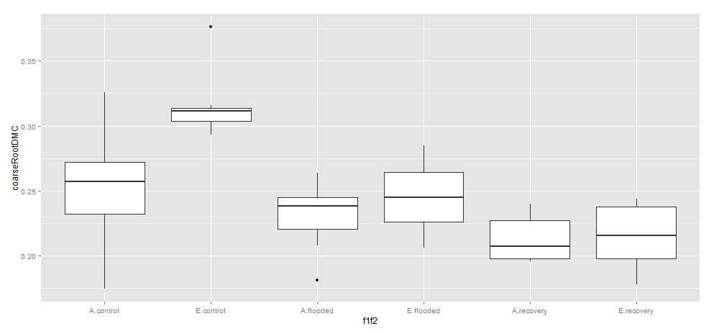

*fineRootDMC*

$CO2

diff lwr upr p adj

E-A 0.04506294 0.01017069 0.07995519 0.0126409

**Eucalyptus**

*coarseRootDMC*

Fit: aov(formula = coarseRootDMC ~ treatment * CO2, data = traits.E)

$treatment

diff lwr upr p adj

flooded-control -0.086838377 -0.1180087 -0.05566801 0.0000001

recovery-control -0.078680413 -0.1102876 -0.04707320 0.0000011

recovery-flooded 0.008157964 -0.0219251 0.03824103 0.7881079

$CO2

diff lwr upr p adj

E-A 0.008086999 -0.01284354 0.02901754 0.4396982

$`treatment:CO2`

diff lwr upr p adj

flooded:A-control:A -0.0818699754 -0.13680823 -0.02693172 0.0008505

recovery:A-control:A -0.0698971242 -0.12483538 -0.01495887 0.0058355

control:E-control:A 0.0178254563 -0.03891453 0.07456544 0.9339088

flooded:E-control:A -0.0744195816 -0.12791455 -0.02092461 0.0020765

recovery:E-control:A -0.0696382460 -0.12457650 -0.01469999 0.0060734

recovery:A-flooded:A 0.0119728511 -0.04110255 0.06504825 0.9838373

control:E-flooded:A 0.0996954317 0.04475718 0.15463369 0.0000401

flooded:E-flooded:A 0.0074503938 -0.04412962 0.05903041 0.9979554

recovery:E-flooded:A 0.0122317294 -0.04084367 0.06530713 0.9822234

control:E-recovery:A 0.0877225805 0.03278432 0.14266084 0.0003177

flooded:E-recovery:A -0.0045224573 -0.05610247 0.04705756 0.9998189

recovery:E-recovery:A 0.0002588782 -0.05281652 0.05333428 1.0000000

flooded:E-control:E -0.0922450378 -0.14574001 -0.03875007 0.0000952

recovery:E-control:E -0.0874637023 -0.14240196 -0.03252545 0.0003320

recovery:E-flooded:E 0.0047813356 -0.04679868 0.05636135 0.9997619

*fineRootDMC*

$treatment

diff lwr upr p adj

flooded-control -0.059784413 -0.11894460 -0.0006242314 0.0471573

recovery-control -0.056347769 -0.11633706 0.0036415247 0.0694234

recovery-flooded 0.003436644 -0.05365988 0.0605331655 0.9882630

*stemDMC*

$treatment

diff lwr upr p adj

flooded-control -0.017703391 -0.03516555 -0.0002412337 0.0463073

recovery-control -0.011135767 -0.02884265 0.0065711174 0.2880320

recovery-flooded 0.006567624 -0.01028541 0.0234206561 0.6136894

$CO2

diff lwr upr p adj

E-A 0.0165704 0.004844761 0.02829603 0.0067408

*SLA (strange value for E39)*

Fit: aov(formula = SLA ~ treatment * CO2, data = traits.E)

$treatment

diff lwr upr p adj

flooded-control 1.566833 -1.892984 5.0266504 0.5187937

recovery-control -1.658981 -5.167287 1.8493242 0.4895163

recovery-flooded -3.225815 -6.564944 0.1133154 0.0601789

*LDMC*

$CO2

diff lwr upr p adj

E-A 0.02719394 0.01163275 0.04275513 0.0010442